**­­UTI Detection Plus Antibiotic Resistance in a Rapid Affordable Test**

**A New Approach**

Urinary tract infections (UTIs) are the most common bacterial infections worldwide. UTI infections can range from mild, recurrent, to complicated. Uncomplicated (mild) UTI typically occur in healthy individuals and are usually easily treated with antibiotics (1,2) but recurrent and complicated UTIs require advanced diagnostic techniques to assist physicians in the diagnosis and the selection of the optimum treatment strategy. UTIs are found in patients of all ages and sexes and involve inflammation of the urinary tract (3). Urinary tract infection can occur in any part of the urinary system which involves the kidneys, urethra, bladder and urethra, but most infections involve the lower urinary tract (the bladder and the urethra). Women are at greater risk of developing a UTI than men based on a variety of factors, including female anatomy. If an infection is limited to the bladder, it can be painful and annoying, but serious health issues result if a UTI spreads to the kidneys. If UTIs are left untreated or are treated inappropriately, infection can affect the upper urinary tract resulting in long lasting effects. Defining a UTI can be complex because numerous clinical and diagnostic parameters can be involved (4). In clinical practice, a UTI diagnosis is based on a range of factors, including symptoms, clinical indicators, and diagnostics tests.

Although clinical symptoms such as frequent and strong urge to urinate, burning sensation while passing urine, abdominal pain when urinating, as observed in most UTIs, asymptomatic UTIs also occur. especially in older women with recurrent and complicated UTIs. This observation points to the unmet need of faster, accurate diagnostic tests able to detect polymicrobial infections which are often the cause of complicated UTIs. Until recent advances in diagnostic testing, UTI were detected by urine dipstick tests which detect nitrate, leucocyte esterase, protein, and red blood cells, or microscopy to identify red blood cells, bacteria, and other organisms associated with UTIs. When positive results were found, a urine culture-based method was deployed to identify the particular species of the bacteria or fungi present and estimate the quantity of the pathogen in the sample. Urine culture and phenotypical biochemistry has been the gold standard, but limitations are well known (6x) and test results are not available for 1-2 days resulting in the frequent use of broad-spectrum antibiotics versus targeted treatments. Today, rapid and accurate detection of pathogens and antibiotic resistance gene (ARG) markers can be performed by molecular techniques using PCR to detect the presence of causative pathogens and antibiotic resistant genes. Multiplex PCR has been shown to be a better technique as compared to conventional urine culture (7). Results are available in five to seven hours, are semi-quantitative, and the methodology is capable of accurately detection multiple pathogens in a specimen beyond what is typically considered positive in a urine culture test.

**A New Approach**

Today, we want to introduce you to a new approach to multiplex UTI pathogen and ARG marker detection using an innovative and propriatary microarray technology, D3 Array. PathogenDx’s D3 Array is Dynamic, Dimensional, Detection (D3). It combines a unique microarray structural architecture that significantly increases sensitivity, with detection and discrimination of pathogens and ARG markers by concurrent room temperature hybridization. This new approach to UTI detection is the PathogenDx D3Array - UTI.

**What Makes D3- UTI Array Unique**

**An Array in every well:** There is an array in every well of a 96 well plate. In the figure below you can see a 24x24 array in each well that utilize up to 576 probes to detect multiple pathogens and other molecular markers of interest in a single well. The D3Array-UTI is a 21X21 array that detects 26 bacterial and fungal pathogens, controls, and 12 classes of ARG markers in triplicate. Today, you can test 48 patient samples per plate but with a Gen2 version of this array, the capacity will increase to 96 samples per plate with the dual hybrid-ization of pathogens and ARG markers on the same array.

**The Array Architecture:** In typical microarrays, probes are printed on a substrate (glass, film or plastic) in a distinct rigid pattern. Recognition and binding of the target pathogen nucleic acid is often slowed down or inhibited due to the stearic hindrance created. Although effective, the limitation of binding sites can reduce sensitivity and longer reaction times are needed to optimize binding of probes and targets.

PathogenDx has solved these constraints with an innovative proprietary approach to microarray architecture. Instead of a flat two-dimensional array, the PathogenDx team, using a proprietary assembly process, have created a three-dimensional lattice array. Unmodified oligonucleotide probes self-assemble into a three-dimensional lattice. These probes are at a sufficient distance from the substrate surface and spaced far enough apart in the array architecture, that they are free to form a duplex pairing with a solution state target nucleic acid strand in the 3D matrix. The result is greatly reduced stearic hindrance or electrostatic inhibition and enhanced sensitivity.

To make all this happen, oligonucleotide probes are synthesized with the desired sequence, and manufactured with a string of “T” bases at each end to generate a final probe construct. During microarray printing, the “T-tailed” oligonucleotides are mixed with a long Poly-dT oligomer which is modified with a tracker dye (CY5) at one end. Immediately upon microarray printing, the water in the printed spot evaporates, leaving a dried 100um “spot”, where the spacing between the oligonucleotides is defined. The dried oligonucleotide spot is approximately100 oligonucleotides thick.

The dried probe spots are stable but at this stage are unlinked to the surface. To create a stable 3D assembly, microarrays are UV crosslinked using a well-established process of photochemical dimerization. The resulting DNA crosslinks are targeted to the “T-Tails” and the Poly-T linker, and a 3D polymeric matrix is created. In a similar fashion, the same UV crosslinking also fixes the spot permanently at its original location. By controlling the components and processes, the physical structure of all spots are identical, creating a loose, polymeric network.

The dried array assembly is stable. When the desired test is initiated by the addition of pathogen or ARG marker nucleic acid in solution, the chemical solutions are removed during a routine “pre-hybridization” wash, resulting in a loose, porous structure within each spot that is ready to engage in hybridization.

**The ability to determine the species of a large panel of pathogens as a single test is novel and uses a very different approach than tests that use qPCR or sequencing. The D3 Array technology is based on simultaneous amplification of multiple ribosomal gene regions known to contain sequence changes that are species specific (well-known rDNA hypervariable domains). Pathogen Dx has demonstrated that a single multiplex PCR reaction that is targeted to HV3 and HV6 (in 16S) and an analogous HV region in 28S (for fungi) can generate amplicons which can be used to ‘Detect and Discriminate’ individual Bacterial or Fungal pathogens in a way that is more specific than what can be done using better-known qPCR reactions, because this novel approach requires that the DNA from any species of interest must simultaneously hybridize to all members of a set of probes, each chosen to be specific to that species only. For the UTI assay, with 26 pathogens of concern, each species is ‘Detected and Discriminated’ from pathogens by simultaneous hybridization to approximately 4 probes for each species at the same time. This 4-fold redundancy produces specificity that is equal or better to any seen in optimized qPCR reactions. PathogenDx D3Array-UTI is achieving this level of specificity and sensitivity in an array where 26 such tests are being performed in each of the 96 arrays in a 96-well plate. The final probe spot of D3 Array-UTI comprises 390 probes in a 21 x 21 array, one each in each well of a 96 well plate.

**A Novel Approach to Quantitation:** The D3Array - UTI assay also deploys a novel and innovative approach to quantitation. The test uses an analogous internal synthetic standard to convert probe hybridization signals to cell copies/sample. Both the quantitation standard and pathogen nucleic acid undergo PCR amplification. The PCR products of both undergo hybridization. The ratio of the signals measured for the quantitation standard and pathogen, defines the quantity of DNA molecules for each pathogen in a sample. PathogenDx’s proprietary software, Augury, calculates the quantity of cells/reaction. Quantitation spans 4-5 logs with a dynamic range of 102-106 cells per reaction. Results are reported in ranges; <10,000 cells/mL, 10,000-100,000, 100,000-1,000,000, and 1,000,000-10,000,000 cells/mL. Below is a graph that demonstrates the process.

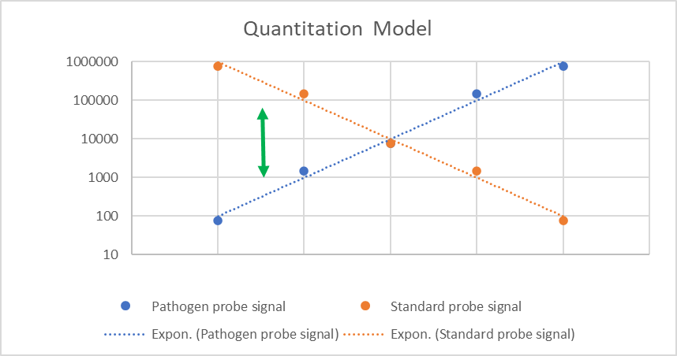

Increasing Signal from Probe(s)

Increasing level of Pathogen contamination

Pathogen

Standard

**1>**

Pathogen

Standard

**>1**

**Imaging, Reporting and Data Analysis:**

Hybridization of target nucleic acid with probes is detected and visualized through high power LEDs using a red-green imager. Green fluorescent spots indicate a positive signal and red spots indicate probe location. PathogenDx’s proprietary software, Augury™, automates the entire process and provides both an easy-to-understand summary report while also providing access to raw data if required. Augury™ is autonomus, and cloud-based and can perform data extraction in minutes. Pre-determined thresholds establish cut-offs for on/off signals. Each tiff image has numerous probe spots that are examined at the pixel level. Augury™ reports the total image intensity for each printed spot. The median of the triplicate spots for each target is the reported probe score. Threshold values are based on CLSI guidelines, and each sample result is displayed for quick viewing. Results for UTI pathogen detection and the related ARG results are aligned so the status for each sample; Detected, Not Detected, can be easily correlated. Augury™ is a powerful tool that fully automated the manual review process that is required for current qPCR data analysis. Total time for analysis of a full plate is approximately one hour and is fully automated. Hands on time is two minutes that requires loading the plate on the imager and clicking the mouse. Reporting is assessed via an on-line portal.

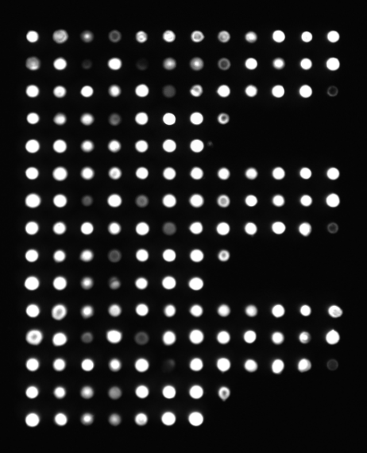

*Figure Key:* Red Circle: Negative Control; Blue Circle: PCR Positive Control, Green Circle: Target Hybridization Spot

**Pathogens and ARG classes that are included in the D3 Array-UTI**

*Bacterial Species:*

* Acinetobacter baumanni
* Aerococcus urinae
* Citrobacter (freundii, koseri)
* Enterobacter (aerogenes, cloacae)
* Enterococcus (faecalis, faecium)
* Escherichia coli
* Klebsiella (oxytoca, pneumoniae)
* Morganella morganii
* Mycoplasma (homis, genitalium)
* Proteus (mirabilis, vulgaris)
* Providencia stuartii
* Pseudomonas aeruginosa
* Serratia marcescens
* Staphylococcus(aereus, saphophyticus)
* Steptococcus agalactiae
* Ureaplasma (parvum, urealyticum)

*Fungal Species:*

* Candida (albians, glabrata)

*Antibiotic Resistance Gene Markers:*

* Tetracycline (tetM)
* ESBL (blaTem, bla,SHV, blaCTX-M-1)
* Trimethoprim (drA1)
* Methicilin (mecA)
* Quinolone (Gyrase A)
* Aminoglycosides (aac6-1b-cr)
* Amplicillin (blaACT)
* Vancomycin (vanA)
* Carbapenum (OXA-48)
* Colistin (mcr-1)

**Laboratory Workflow:**

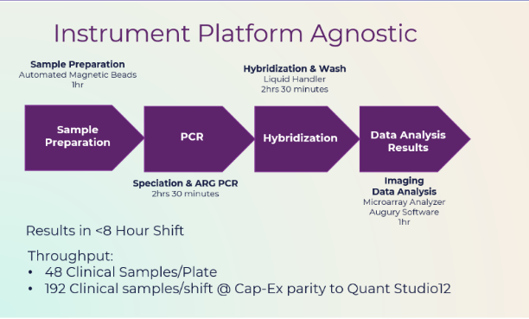Sample preparation to results in a single shift. D3 Array-UTI is instrument platform agnostic enabling easy integration into the existing molecular testing laboratories and creating flexibility for laboratories new to molecular testing. Any of the many established sample preparation methodologies can be used, the most common being automated magnetic bead-based systems. Sample processing typically takes approximately one hour. Purified DNA is amplified using any standard thermocycler for approximately two and on-half hours. The PCR products are transferred to the D3 Array for hybridization. This step can be performed manually but for large sample volumes, a liquid sample handler (robot) can easily be programed to perform the required wash steps. Hybridization is at room temperature and takes approximately two- and one-half hours. The D3 Array plate is imaged using a red/green fluorescence microplate imager, and the data analyzed by PathogenDx’s proprietary Augury™ software tool.

**Cost-Effective, No Waste:** Each sample only requires two wells of a 96 well plate, one for pathogen detection, and one for ARG detection. Forty-eight samples can be tested on a single plate. The Gen2 version of the test will combine pathogen and ARG detection in a single well, increasing the plate capacity to 96 samples. Everything needed for analysis (target specific probes & controls, in triplicate) exists on each array in a single well of the plate. The plate is foil covered and only the wells you need are used. You can test one sample and store the D3 Array plate for later use. There are no wasted wells. Simplified workflow, no special instrumentation, no wasted wells, automated data analysis and reporting, all contribute to a lower cost solution for UTI Molecular testing.

**A New Cost-Effective and Innovative Approach to UTI and Related ARG Detection**

PathogenDx D3Array™-UTI addresses the challenges laboratories using qPCR approaches to UTI and ARG testing deal with every day. The novel D3 Array -UTI test is built upon well-established molecular technologies configured into a test system to address known limitations and challenges of qPCR. The unique spatial architecture, and the methodology to ‘Detect and Discriminate’, combined with Augury™, PathogenDx’s powerful data management SW tool, creates an innovative and patented new approach to multiplex testing that cuts waste and cost while providing accurate UTI and ARG results. Analytical performance studies have documented sensitivity and specificity that matches or exceeds comparator UTI multiplexed assays with clinical concordance when compared to a well-established assay in a third-party laboratory, averaging >95% for pathogen detection and >98% for ARG marker detection.