**Corporate Office**

9375 E Shea Blvd, Suite 100

Scottsdale, AZ 85260  
Phone: (800) 641-5751

www.pathogendx.com

**Research & Development**

1230 E. Pennsylvania Street, Ste 102

Tucson, AZ 85714

**Rapid, Affordable, High Throughput Approach to Multiplex Testing of Salmonella spp and Salmonella Serovars with PathogenDx** **D3 Array™ Technology**

**By Dr Mike Hogan, Chief Scientific Officer, Dr. Susan Evans, Clinical Advisor, and Dr. Benjamin A Katchman, VP of Product Development**

**A New Approach**

Today, we want to introduce a new approach to nucleic-acid-based pathogen testing: based on a proprietary microarray technology, the PathogenDx’s D3 Array™ (***D***ynamic ***D***imensional ***D***etection). It enables Detection, Discrimination and Semi-Quantitation of microbial pathogens by combining a novel approach to multiplex PCR with a patented microarray architecture. That combination allows the use of unpurified DNA as the analyte in a way that simplifies sample workflow and significantly increases sensitivity: thereby enabling ***enrichment free*** analysis of microbial pathogens from plant and animal isolates with a LOD as low as 1CFU/mL of 1 CFU/gram. This new approach to multiplex testing has been built into the full portfolio of PathogenDx kits for regulated microbial compliance testing: including agricultural matrices; environmental monitoring; and most recently, for the regulated analysis of Salmonella spp and serovars in Chicken and Turkey, to satisfy standards recently proposed by the USDA. This new approach to Salmonella serovar testing, trademarked as “SeroX,” will be highlighted in this paper.

**Salmonella Serovar Contamination of the Poultry and Turkey Processing Supply Chain.**

Salmonella contamination has risen as a top priority in the food chain, driven by the emergence of pathogenic Salmonella variants, “Serovars” which, increasingly, have been selected (by poor antibiotic stewardship) to become resistant to antibiotic treatment of animals and in the human consumer. The evolution of the Salmonella problem has recently compelled the USDA to suggest that it is not enough to simply detect total Salmonella contamination (Salmonella spp) but instead, it becomes crucial to Detect and Discriminate the presence of specific, pathogenic “Salmonella Serovars,” as a routine test throughput in the food supply chain, especially in the processing of Chicken and Turkey, which are both highly prone to Salmonella infection.

Additionally, and perhaps as importantly, testing throughput has become a major concern. The poultry supply chain has become highly industrialized, processing thousands of poultry carcasses per hour in a single factory, to be shipped to national and international retail markets. Historically, when poultry processing was still a local or regional process, traditional methods of culture based microbial analysis would suffice, in that they provided a slow, but reasonably simple way to detect a single type of Salmonella, over the course of 24 hrs. But more recently, because of the speed, centralization and capacity of the modern poultry supply chain, the traditional culture-based methods are now seen as being too slow and logistically challenging to Detect and Discriminate multiple Serovars fast enough to support Just-in-Time automated poultry processing and distribution.

**Enrichment-Free Salmonella spp and Serovar Testing Enabled by D3 Array Technology**

The design and deployment of SeroX is a direct extension of similar D3 Array-based tests already developed and commercialized by PathogenDx for the Detection, Discrimination and Quantitation of bacterial, fungal and viral pathogens. All are based on the requirement to deliver a true polymicrobial test, without culture based enrichment, delivering a limit of detection near 1CFU/gram/mL as required by regulatory standards. To date, these PathogenDx tests have been awarded AOAC PTM certification for enrichment free pathogen detection at 1CFU/gram/mL.

**Design Principles Behind SeroX**

**Short Term Strategic Focus.** On July 29, 2024, the USDA provided guidance that it looks to regulate Salmonella spp for final finished processed poultry and turkey before it is shipped to the retail market, and will also include Salmonella species (Salmonella spp) as required presently but will also be expanded with the added requirement of (5) Serovars. Three of these would be tested on chicken for *Typhimurium, Enteritidis, Typhimurium monophasic.* And three Serovars for turkey*, Typhimurium, Hadar and Muenchen.* In anticipation of those (likely) changes to regulation, we have begun development of a “Regulated” SeroX test that will Detect and Quantify Salmonella spp, along with all (5) of the additional serovars as called out by the USDA. As embodied in all other PathogenDx tests for Food and Agriculture applications, SeroX is based on the D3 Array™ platform, in the 96-well format, and is based on sample preparation from poultry rinsates without enrichment culture.

**Longer Term Regulatory Considerations**

**Addition of Vaccine genes to Regulated Serox**

There are at least 2,500 known Salmonella Serovars, both natural and man-made. We are building into SeroX the capacity to accommodate a much larger set of “Serovars of Concern.” The first of such additional serovars can be seen in our present “Regulated” SeroX test, where we propose to add the (2) commercial live, attenuated Salmonella poultry vaccine Serovars (PoulVac St and Megan Vac 1) and the profoundly antibiotic Typhimurium variant DT104, which has been a required Salmonella test in Canada and in the EU for several years and could become part of USDA requirements at some point.

**Research Use Only SeroX.**

Beyond *Enteriditis*, *Typhimirium* and *I4,[5],12:i*:- (*Monophasic Typhimirium*), *Muenchen*, and *Hadar*, the USDA noted that the following “Serovars of Concern” also contributed to 85% of human infections: *Heidelberg*, *Montevideo*, *Infantis*, and *Thompson*.

We have also chosen to develop and sell a “RUO” version of the Serox test. It includes the same content as the “Regulated” Serox test, but comprises a larger set of “Serovars of Concern” especially those which are known to be highly pathogenic in humans, but not yet of direct regulatory concern. It is envisioned that this RUO test would have substantial epidemiological value and useful as an industrial QC tool in poultry processing, to monitor the extent of Salmonella contamination, and can be added to the Regulated Serox over time in the same assay. Thereby avoiding the need to run 2-3 different qPCR assays to comply to the full complement of Serovars.

**Laboratory Workflow**

The guidance from the USDA is that *Salmonella spp* contamination should remain <10CFU/g/mL (carcass) and for specific serovars <1CFU/g/mL (carcass) and that such pass/fail evaluation should be performed before the processed meat is shipped. Traditional culture-based testing can readily achieve the required analytical sensitivity, but only after a day or more of enrichment culture, thus requiring that processed poultry would be quarantined for at least a day before shipping, thereby losing a day of shelf life and introducing a substantial upgrade in cold storage capacity. In fact, the USDA MLG method is the only traditional culture method accepted and would take 5 days to deliver a result. A culture free test such as SeroX can be completed in less than 6-8 hrs (depending on number of samples), thus eliminating the need for quarantining product, if it can be configured to Detect and Discriminate Serovars at the 1CFU/g/mL limit, which based on simple counting statistics requires that a substantial fraction of a standard carcass rinsate can be tested.

**SeroX Analysis of Poultry Carcass Rinsate.**

We have embedded the strength of the D3 Array™ technology into the current industry standard for poultry carcass rinsate collection. Briefly, a standard rinsate is used. An aliquot of the rinsate is transferred to a conical tube and concentrated by benchtop centrifugation. A bacterial pellet is produced in each tube which is suspended in Lysis Buffer and transferred to a microfuge tube and then centrifuged to produce a rinsed pellet. The supernatant is removed and the pellet is resuspended in lysis buffer is added to the pellet followed heating to lyse bacteria. The rinsate samples are now ready for One Step Endpoint PCR, followed by Hybridization analysis on all samples in parallel. The D3 Array™ plate is imaged using a red/green fluorescence microplate imager, and the data is analyzed by PathogenDx’s proprietary Augury™ software. The resulting data is automatically transferred to a secure portal for storage, curation and sharing.

**What Makes D3 Array™ Technology Unique?**

**An Array in every well:** **D3** technology placesan array in every well of a 96-well plate. In the figure below you can see a 24x24 array in each well that presents up to 576 individual synthetic DNA oligonucleode probes—to detect multiple pathogens and other molecular markers of interest in a single well. The D3 Array™ can interrogate a minimum of 3 targets (3x3 array) or up to 192 targets (24x24). Bacterial, fungal and viral targets are tested in triplicate to ensure high-quality assurance of the result. Today, you can test 96 samples per plate, delivering the highest level of throughput for multiplex assays.

Figure 1. Representative Top View of D3 Array and Illustration of D3 Array Architecture.

**D3 Array™ Architecture:** In typical microarrays, probes are printed on a glass, film or plastic substrate in a distinct rigid two-dimensional pattern. Recognition and binding of the target pathogen nucleic acid is often slowed down or inhibited due to the steric hindrance created by proximity to the surface, to limit target access to the probe binding sites, thereby reducing sensitivity and slowing the hybridization process.

PathogenDx diminished those steric constraints with an innovative proprietary approach to microarray architecture. Instead of a flat two-dimensional array, the PathogenDx team, has created a three-dimensional lattice array, formed by self-assembly of unmodified oligonucleotide probes to form a micron scale three-dimensional lattice. In that lattice, probes are at a sufficient distance from the substrate surface and spaced far enough apart in the array architecture, that they are free to form a more open duplex pairing with a solution state target nucleic acid strand. The result is greatly reduced steric hindrance or electrostatic inhibition and enhanced sensitivity.

To make all this happen, each oligonucleotide probe is synthesized with the desired sequence and manufactured with a string of “T” bases added to each end, to generate a final probe construct. During microarray printing, the “T-tailed” oligonucleotides are mixed with a long Poly-dT oligomer which is modified with a tracker dye (CY5). Immediately upon microarray printing, the water in the printed spot evaporates, leaving a dried 100 µm “spot,” where the spacing between the oligonucleotides is set by the amount and nature of the print buffer.

The dried probe spots are stable but at this stage are unlinked to the surface. To create a stable 3D assembly, microarrays are cross-linked using a well-established process of photochemical dimerization. The resulting DNA crosslinks are targeted to the “T-Tails” and the Poly-T linker, and a 3D polymeric matrix is created. The same crosslinking also fixes the spot permanently to the underlying surface at its original location. By controlling the components and processes, the physical structure of all spots become identical, creating a loose, polymeric network within each.

The crosslinked array assembly is stable when dry. The desired 3D test structure is initiated during a routine “pre-hybridization” wash, causing the crosslinked oligonucleotide assembly to swell, thus producing a loose, porous structure within each spot that is ready to engage in hybridization.

**Cost-Effective, No Waste:** Each sample only requires one well of a 96-well plate. Ninety-six samples can be tested on a single plate. Everything needed for analysis (target specific probes & controls, in triplicate) exists on each array in a single well of the plate. The plate is foil covered and only the wells you need are used. You can test one sample and store the D3 Array™ plate for later use. Simplified workflow, no special instrumentation, no wasted wells, automated data analysis and reporting, all contribute to a lower cost solution for multiplex, high-throughput, low-cost testing.

Figure 2. Microarray with Removable Foil Cover, Providing Simple, Cost-Effective Flexibility.

**A New Cost-Effective and Innovative Approach to Pathogen Detection**

PathogenDx D3Array™ addresses the challenges laboratories have using traditional plate culture and qPCR approaches to pathogen testing. The novel D3 Array™ test is built upon well-established molecular technologies configured into a simple-to-use and robust test system to address known limitations with existing technologies. The unique spatial architecture, and the methodology to ‘Detect and Discriminate,’ combined with Augury™, PathogenDx’s powerful data management software tool, creates an innovative and patented new approach to multiplex testing that cuts waste and cost while providing accurate results.

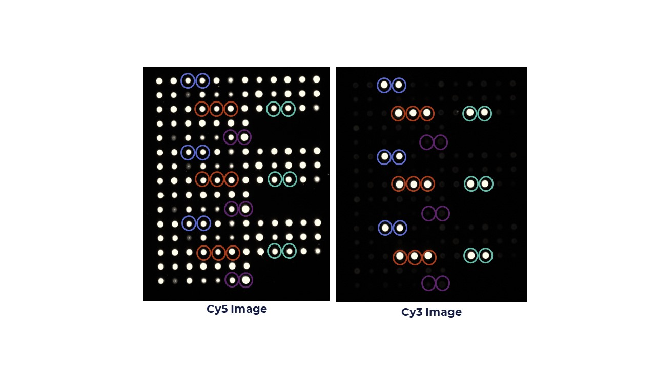In the D3 Array™ format, hybridization of target nucleic acid with probes is detected and visualized through high- power LEDs using a red-green imager. Green (Cy3) fluorescent spots indicate a positive signal, and red (Cy5) spots indicate probe location. Our PathogenDx proprietary software, named Augury™, automates the entire process and provides both an easy-to-understand summary report as well as access to raw data if required. The Augury™ software can perform data analysis on an array in 10sec=15min for a full 96-well plate. Hands on time is two minutes, only requiring the analyst to load the plate on the imager and click the mouse. Reporting is accessed via a secure on-line portal.

Figure 3. Representative Image of D3 Array. Blue Circle: Internal Positive Control. Purple Circle: Internal Negative Control. Green and Red Circles: Species or Serovar Specific Probe Spots.

Each tiff image has numerous probe spots that are examined at the pixel level. Pre-determined thresholds establish cut-offs for on/off signals. Augury™ reports the total image intensity for each printed spot. The median of the triplicate spots for each target is the reported probe score. Threshold values are based on guidelines, and each sample result is displayed for quick viewing. Results for pathogen detection are aligned so the status for each sample, Detected or Not Detected, can be easily correlated. Augury™ is a powerful tool that fully automates the manual review process that is required for current qPCR data analysis.

**A Novel Approach to Quantitation**

The D3 Array™ assay also deploys a novel and innovative approach to quantitation. The test uses an analogous internal synthetic standard to convert probe hybridization signals to cell copies/sample. Both the quantitation standard and pathogen nucleic acid undergo PCR amplification. The PCR products of both undergoes hybridization. The ratio of the signals measured for the quantitation standard and pathogen probe defines the quantity of DNA molecules for each pathogen in a sample. PathogenDx’s proprietary software, Augury™, calculates the quantity of cells/reaction. Below is a graph that demonstrates the 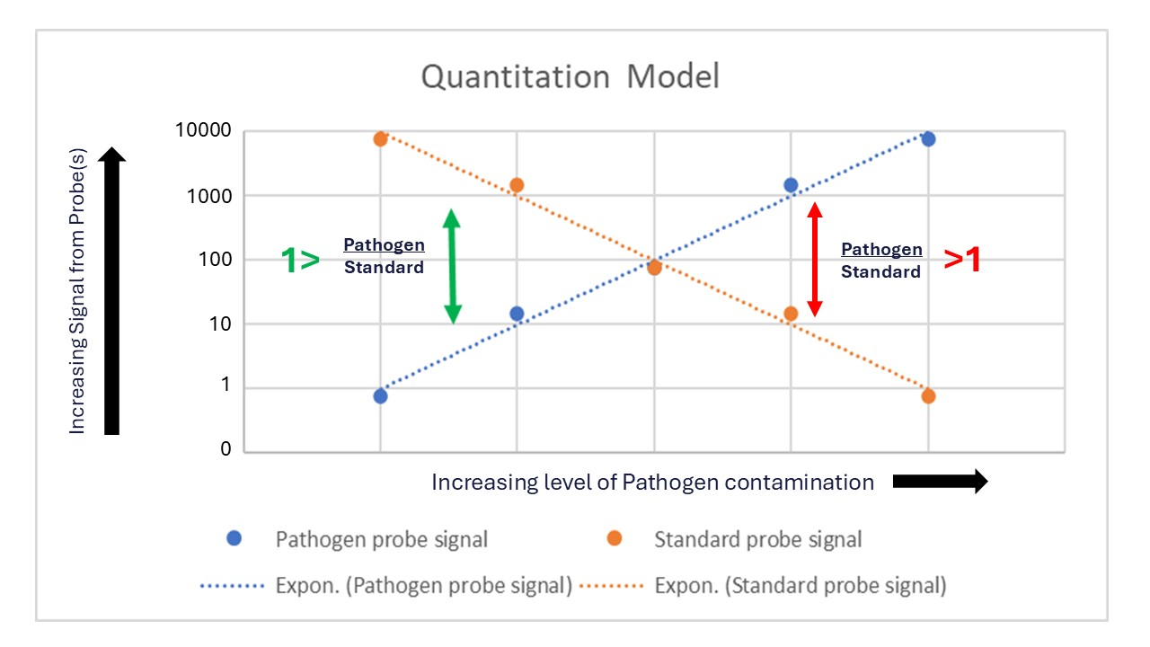process.

Figure 4. Quantification utilizes internal standards to provide rapid and accurate detection and quantification of multiple species/serovars in a single well.

**D3 Array™ Technology vs qPCR**

At present, the dominant PCR-based technology for microbial testing is real-time qPCR, most generally the TaqMan deployment. TaqMan PCR is based on the direct coupling of PCR amplification and nucleic acid probe hybridization, all in the same tube in solution. The PCR drives hybridization of a fluorescently tagged oligonucleotide probe inside the PCR chamber. Upon binding to the amplicon produced by PCR, the TaqMan probe becomes fluorescent. Although elegant in its simplicity, qPCR begins to falter when pushed to detect very low levels of microbial DNA contamination, which generally requires the ability to detect a single microbial gene copy per PCR reaction. There are three main reasons for those LoD limitations in qPCR:

**A).** qPCR is a type of real-time PCR and delivers its data (a Cq value) early in the PCR process, generally before most of the PCR products that could have been amplified have been allowed to do so.

**B).** qPCR places substantial restrictions on the design of the fluorescently tagged Probes that enable detection of the microbial analyte. These restrictions result from the fact that the Probes are forced to bind to the amplicon target during the PCR reaction, generally at 65°C. At 65°C, the hybridization of the Probe to the amplicon target is weakened by the heating process itself, thus raising the LoD above the value that would have been obtained if probe binding could have occurred at Room Temperature (25°C), 40°C lower.

**C).** A third class of weakness in qPCR begins to manifest when the assay of interest is polymicrobial: i.e. the test needs to Detect and Discriminate pathogens in a test panel that may include dozens of bacteria or yeast. qPCR can be multiplexed to detect only 2-4 pathogens in parallel, due to technical limitations of the qPCR reaction itself. When pushed to Detect more than a small number of pathogens, the sample must be split into multiple separate qPCR reactions that are performed separately. To save cost and miniaturize the logistics of such polymicrobial testing, it is now possible to set up multiple qPCR reactions in 384-well and even 1534-well formats, thereby performing a very large number of individual (very small volume) qPCR reactions in parallel. Such miniaturization is elegant but does not obviate the core LoD limitations of qPCR, namely that the LoD remains at ~10 gene copies/reaction. Thus, although it is now routinely possible to perform polymicrobial testing in qPCR reactions as small as 1 µL (or less), the resulting LoD at that small scale becomes even higher. The math is unavoidable: 10 gene copies/reaction x 1 µL = 10+4 gene copies/mL, which is much higher than the microbial loads allowable in food safety testing. For that reason, nearly all commercial qPCR tests used presently in the food safety testing market require cultural enrichment (16-36 hrs) prior to the actual qPCR test, to achieve a microbial load up to the 10+4 gene copy/mL limit imposed by the deployment of small volume qPCR.

**How D3 Array™ Technology Coupled to Endpoint PCR Mitigates the major LoD limitations of qPCR.**

We address the advantages here in the same order as we have discussed qPCR.

**A).** **Real Time vs Endpoint PCR**. All D3 Array™ reactions are based on Endpoint PCR, the “Endpoint” appearing near the end of a PCR reaction, where the amount of amplified product is >10x greater than the earlier stages of the reaction where Cq values are obtained. Thus, the use of endpoint PCR gives the PathogenDx technology an immediate 10x LoD advantage relative to qPCR in terms of the amount of amplified DNA product available for pathogen detection.

The use ofEndpoint PCR and its utilization in D3 Array™ technology is both sophisticated and simplified. D3 Array™ PCR deployment is a multiple step multiplex PCR reaction, comprising three steps, which occur in series and can be performed in a single tube.

**The three steps are:**

**1)** **Uracyl DNA Glycosylase (UNG) treatment** of DNA template prior to PCR. This reaction destroys any lab contamination of the sample by D3 Array Tests performed previously, thereby eliminating accidental cross contamination.

**2)** **Symmetric Multiplex PCR amplification** (20-30 cycles) of the UNG-treated product with multiple PCR primers to produce a multiplex amplicon product.

**3)** **Asymmetric PCR amplification** (>20 cycles) of the multiplex PCR product with dye labelled PCR Primer pairs, with each dye labelled primer in 4x excess, so that near the end of the “Asymmetric” reaction, the unlabeled primer is exhausted, and amplification is driven exclusively by the dye labelled primer in 4x excess. The resulting PCR product thus becomes “Asymmetrically” amplified with 75% of the amplicon product being dye-labelled and single stranded and thus ready to be delivered to the D3 Array™ for hybridization without heating or other processing steps.

**B).** **TaqMan Probes work at 65°C vs D3 Array Hybridization Probes work at 25°C**. TaqMan probes are constrained to function inside a PCR reaction: typically, at 65°C. The D3 Array™ technology allows Endpoint PCR products to be hybridized without such constraints, separate from the PCR reaction, at Room Temperature (40°C below qPCR). The 40°C reduction in temperature allows D3 hybridization probes to bind PCR products at least 10x more tightly than is possible with qPCR, thus delivering a predicted lowering of LoD. Historically that potential microarray benefit was overwhelmed and lost due to the steric impediments associated with linking hybridization probes to a surface, so much so that traditional array hybridization had to be “reheated” to 65°C and deployed in flow cells in order to allow PCR + Array analysis to be performed in less than a day. As discussed above, D3 Array technology obviates both array heating and mechanical mixing, thus retaining its natural >10x LoD advantage vs real time qPCR.

**C).** **Size Matters: A large-volume Multiplex Endpoint PCR reaction is intrinsically more sensitive (lower LoD) than if, as in qPCR, it is broken into multiple reactions that are identical in every way to the original but performed in a much smaller PCR reaction volume.** PCR is unlike other molecular tests, in that the PCR limit of detection (LoD) is in most cases defined by the number of nucleic acid target molecules per reaction, rather than nucleic acid chemical concentration per reaction. For instance, if a 50 µL qPCR reaction containing DNA near its LoD (10 molecules/reaction) is split into smaller volumes (e.g., 50 µL split to 1 µL reactions) each of those 1 µL reactions will now be positioned at a new value (0.2 molecules/reaction), which is 50-fold lower than the original LoD and thus undetectable by qPCR.

All aspects of the D3 Array™ technology have been optimized to take advantage of how PCR sensitivity increases with volume scale-up, to deliver assays that perform polymicrobial testing at or near the theoretical limit of detection. By doing so, D3 Array™ technology allows the Detection and Discrimination of complex sets of bacterial, fungal, and viral pathogens without the need for culture-based enrichment. The D3 Array™ workflow is summarized here with that focus, especially pertinent in the context of Polymicrobial Salmonella Serovar testing in the SeroX test:

**Large Volume sample processing🡪**

Capture and Concentrate the Largest Possible Number of Polymicrobial DNA Targets. Filtration or Centrifugation can be used to collect microbes from samples up to 100mls.

**Large Volume Multiplex Endpoint PCR**🡪

Simultaneously amplify All DNA Targets of Interest in a Single Large Volume PCR Reaction, typically 50uL

**Large Volume D3 Array™ Hybridization**🡪

Transfer 100% of the Large Volume Endpoint PCR Reaction, with no processing and minimal dilution for simultaneous Hybridization to a D3 array (>100 Probes) manufactured at scale on the bottom of a standard large volume, deep well microtiter plate. Hybridization is done simply at room temperature, with no mixing in a standard open microplate.

**In summary,** PathogenDx has developed a new approach to nucleic-acid-based pathogen testing based on a proprietary microarray technology, PathogenDx’s D3 Array™, which enables Detection, Discrimination and Semi-Quantitation of microbial pathogens by combining a novel approach to multiplex PCR with a patented microarray architecture. Below is a list of PathogenDx products for the testing of Salmonella Serovars in Chicken and Turkey as well as for Agriculture matrices and environmental monitoring.

**D3 Array™-Based Microbial Tests**

|  |  |
| --- | --- |
| **DetectX-Combined** | |
| **Bacterial Organisms** | **Fungal Organisms** |
| *Escherichia coli* | *Aspergillus flavus* |
| *Stx* 1 | *Aspergillus fumigatus* |
| *Stx* 2 | *Aspergillus niger* |
| *Salmonella spp* | *Aspergillus terreus* |

|  |  |
| --- | --- |
| **QuantX-Bacterial** | **QuantX-Fungal** |
| Total Aerobic Bacteria | Total Yeast and Mold |
| Bile Tolerant Gram Negative |  |
| Total Enterobacteriaceae |  |
| Total Coliform |  |

|  |  |
| --- | --- |
| **EnviroX** | |
| **Bacterial Organisms** | **Fungal Organisms** |
| Total Aerobic Bacteria | Total Yeast and Mold |
| Bile-tolerant Gram-Negative | Alternaria species |
| Total Enterobacteriaceae | Aspergillus species |
| Aeromonas hydrophilia | Aspergillus flavus |
| Aeromonas salmonicida | Aspergillus fumigatus |
| Bacillus Group 1 | Aspergillus niger |
| Bacillus Group 2 | Aspergillus terreus |
| Campylobacter species | Botrytis species |
| Citrobacter farmeri | Candida albicans |
| Clostridium difficile | Candida tropicalis |
| Escherichia coli | Candida glabrata |
| Shigella species | Candida auris |
| Legionella species | Cladosporium species |
| Listeria species | Fusarium oxysporum |
| Pseudomonas species | Fusarium Splani |
| Salmonella enterica | Golovinomyces |
| Enterobacter species | Kluyveromyces |
| Staphylococcus aureus | Mucor species |
| Streptococcus species | Penicillium Species |
| Streptomyces biofoliar | Penicillium paxilli |
| Xanthomonas species | Sacchromyces species |
|  | Stachybortys species |
|  | Tricoderma species |

|  |  |
| --- | --- |
| **PhytoX**  **Plant Virus and Virions** | |
| Hop latent viroid (HLVd) | Arabis mosic virus (ArMV) |
| Lettuce chlorosis virus (LCV) | Alfalfa mosaic virus (AMV) |
| Cannabis cryptic virus (CanCV) | Tobacco mosaic virus (TMV) |
| Beet curly top virus (BCTV) | Cucumber mosaic virus (CMV) |
| Tobacco streak virus (TSV) |  |

|  |  |
| --- | --- |
| **SeroX** | |
| **Regulated (Chicken/Turkey)** | **RUO** |
| *Salmonella spp* | *Salmonella spp* |
| *Typhimurium* | *Typhimurium* |
| *Enteritidis* | *Enteritidis* |
| *Typhimurium monophasic*  *I 4,[5],12:i:-  (MVST)* | *Typhimurium monophasic*  *I 4,[5],12:i:-  (MVST)* |
| *Hadar* | *Hadar* |
| *Muenchen* | *Muenchen* |
|  | *Newport* |
|  | *Javiana* |
|  | *Heidelberg* |
| **SeroX Content in Development** | *Saintpaul* |
| Quantification of Salmonella spp and regulated serovars | *Montevideo* |
| MeaganVac 1  (crp and cyaA) | *Infantis* |
| PoulVac ST (aero-serC operon) | *Branderup* |
|  | *Oranienberg* |
| *Typhimurium DT104* | *Thompson* |
|  |  |
| ***Salmonella spp***  **+ 5 Serovars** | ***Salmonella spp***  **+ 14 Serovars** |